**Master Copy**

**Manages multiple clipboard objects**

The main idea behind this utility was to save bugs content, along with their

IDs, full text descriptions and screenshots.

For that, I had to have a utility, which will combine multiple types of clipboard objects: text, images and files.

After launching the application, the main screen looks like that:

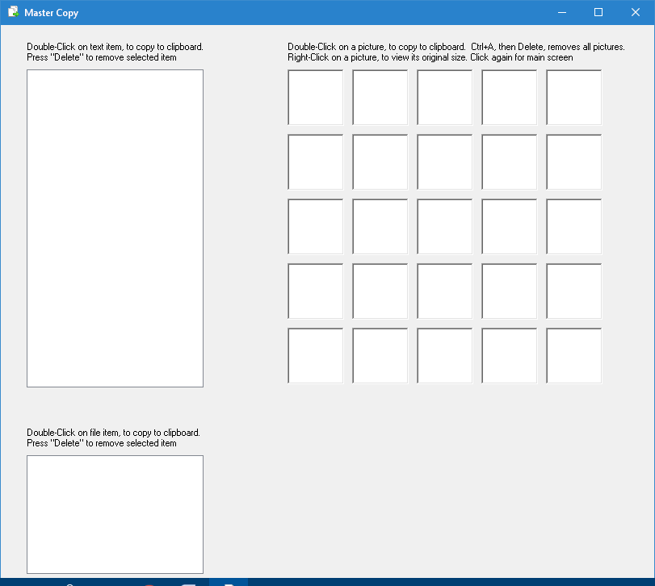

Now, we can:

* **Copy text**: select a single line, or multiple lines and copy to clipboard->

the copied text will be added to the text region (upper-left part), line by line.

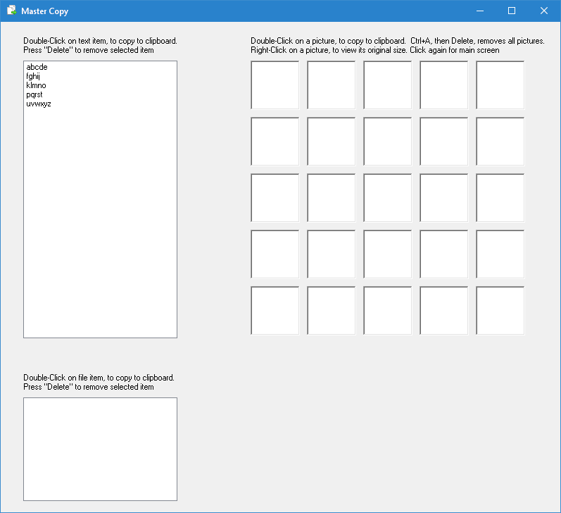

* Double-click on a text line (from the added lines)-> This selects the line and copies it to the clipboard. Now, we can paste it to a code editor.
* Select one or more of the text lines (from the added lines), by highlighting them, then press Delete/Del key-> The selected text lines will be removed.
* **Copy images:** Press the PrintScreen keyboard key (or Alt+PrintScreen key),

to create a screenshot-> the copied picture will be added to the pictures region (upper-right part).

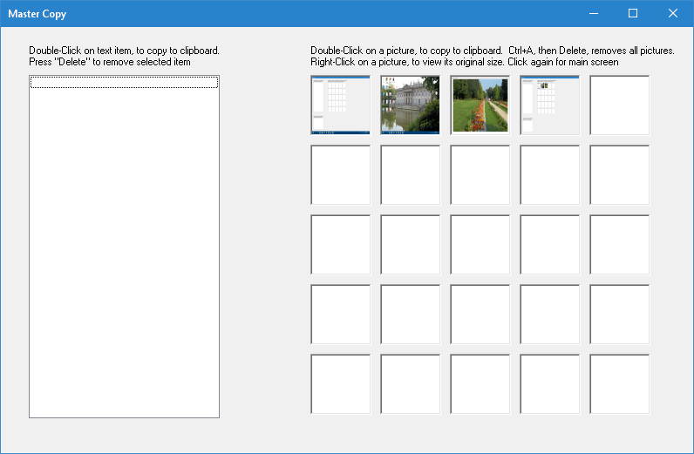

* Double-click on a picture-> This selects the picture and copies it to the clipboard. Now, we can paste it to a photo editor (such as Paintbrush).
* Right-click on a picture-> The selected picture will be shown in its original size. Click again-> we are back in the application's main screen.
* **Copy files:** We can also copy & paste files and directories, in a similar way we do with copying text or images. The built-in app instructions will help us

do that.

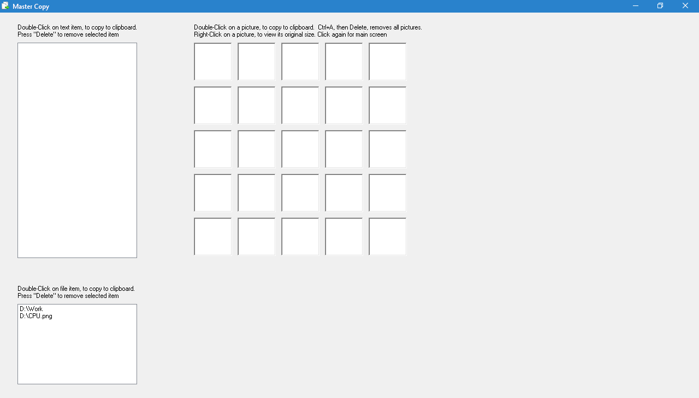

**Code location:** <https://github.com/LiorBob/MasterCopy/blob/master/MasterCopy/frmMasterCopy.cs>